MONEY CONTROL AUTOMATION

YAKSHA

Time To Complete: 3 hrs

**CONTENTS**

1. Problem Statement 2
2. Business Requirements: 2

o 3

1. Implementation/Functional Requirements 3
   1. Code Quality/Optimizations 3
2. Template Code Structure 3
   * a. Package: com.iiht.evaluation.automation 3
   * b. Package: com.iiht.evaluation.automation 3
   * c. Package: com.iiht.evaluation.automation 5
3. Execution Steps to Follow 6
4. **PROBLEM STATEMENT**

Need to automate the following activities using Selenium + Java

1. **BUSINESS REQUIREMENTS:**

Navigate to <https://www.moneycontrol.com/>

1. Mouse hover on Personal Finance and click on “Tools” under Explore.
2. In Tools page, click on “Home Loan EMI Calculator”.
3. Enter the load amount as “3000000”.
4. Enter the load period as 20.
5. Choose “At the time of load disbursement” in “EMI Starts from” dropdown.
6. Enter interest rate as “10.5”.
7. Enter Upfront charges as “10000”.
8. Click on Submit.
9. Print Total payment and EMI in console
10. Under load payment schedule table, print the following details 7th year.
    1. EMI Payment in the Year
    2. Interest Payment in the year
    3. Principal payment in the year.
11. Print “Outstanding Principal at end of year” value for 5th year in the table.

NOTE: "Please do not delete any file in the src folder.  But you are free to add any other file".

**Expectations:**

1. Learners should write automation script using Java and selenium to automate all the steps in the above question. In other words, automation script should perform all mentioned steps.
2. Learners should not use any tools to create the xpath. They should develop the xpath/cssselector on their own.
3. **IMPLEMENTATION/FUNCTIONAL REQUIREMENTS**
   1. **CODE QUALITY/OPTIMIZATIONS**
      1. Associates should have written clean code that is readable.
      2. Associates need to follow SOLID programming principles.

1. TEMPLATE CODE STRUCTURE

**Resources**

* A. PACKAGE: COM.IIHT.EVALUATION.AUTOMATION

|  |  |  |  |  |
| --- | --- | --- | --- | --- |
| **Class/Interface** | | **Description** | | **Status** |
| **App.java(class)** | This represents bootstrap class i.e class with Main method, that shall contain all console interaction with user. | | **Implemented** | |

**Resources**

* B. PACKAGE: COM.IIHT.EVALUATION.AUTOMATION

|  |  |  |
| --- | --- | --- |
| **Class/Interface** | **Description** | **Status** |
| **Activities.java(class)** | **This represents core activities.**  **Following methods are there:** | **Not Implemented** |
|  | **navigateToHomeLoanEMI()** | **Implement to automate the navigation to Loan Calculator page. This method must call mouseOverPersonalFinanc e() method from**  **SubActivities class.** |
|  | **calculateHomeLoanEMI()** | **Implement this method to automate calculation of Home Loan. This method must call following methods from SubActivities class:**  **enterValueLoanAmount() selectEMIStartsFrom()** |

|  |  |  |
| --- | --- | --- |
|  |  | **enterInterestRate() enterValueLoanPeriod() enterValueUpfrontCharges ()**  **clickSubmit()** |
|  | **getTotalPayment()** | **Implement this to get total payment**  **Must call getTotalPaymentElement() method of SubActivities**  **class** |
|  | **getEMI()** | **Implement this to get EMI Must call getEmiElement()**  **method of Helpers class** |
|  | **getTableDetails7thYearEMIPaymen tInTheYear()** | **Implement this to get EMI Payment in the 7th Year Must call getXpathfor7thYearEMIPay ment() of Helpers class to get the manual xPath** |
|  | **getTableDetails7thYearInterestPay mentInTheYear()** | **Implement this to get Interest Payment in the 7th Year**  **Must call getXpathfor7thYearInteres tPayment() of Helpers class**  **to get the manual xPath** |
|  | **etTableDetails7thYearPrincipalPay mentInTheYear()** | **Implement this to get Principal Payment in the 7th Year**  **Must call getXpathfor7thYearPrincip alPayment() of Helpers class to get the manual**  **xPath** |
|  | **getTableDetails5thYearOutstanding PrincipalAtTheEndOfYear()** | **Implement this to get Outstanding Principal at the end of 5th Year Must call**  **getXpathfor5thYearOutsta ndingPrincipalPayment() of Helpers class to get the manual xPath** |

o C. PACKAGE: COM.IIHT.EVALUATION.AUTOMATION

**Resources**

|  |  |  |
| --- | --- | --- |
| **Class/Interface** | **Description** | **Status** |
| **SubActivities** | **This is a class containing helper methods. Following methods needs**  **to be implemented** | **Not Implemented** |
|  | **mouseOverPersonalFinance()** | **Implement this method to automate mouseover on Personal Finance menu. It must call clickTools() method of**  **SubActivities** |
|  | **clickTools()** | **Implement this method to automate clicking on Tools option. It must call clickOnHomeLoanEMIC alculator() method of**  **SubActivities** |
|  | **clickOnHomeLoanEMICalculator()** | **Implement this method to automate activating the EMI calculator.** |
|  | **enterValueLoanAmount()** | **Implement this method to automate entering Loan Amount**  **It must call getElementforLoanAmo unt() method of Helpers**  **class** |
|  | **enterValueLoanPeriod()** | **Implement this method to automate entering Loan Period**  **It must call getElementforLoanPeri od () method of Helpers**  **class** |
|  | **selectEMIStartsFrom()** | **Implement this method to automate entering EMI start option**  **It must call getElementforEMIStart () method of Helpers**  **class** |

|  |  |  |
| --- | --- | --- |
|  | **enterInterestRate()** | **Implement this method to automate entering interest rate**  **It must call getElementforInterestR ate () method of Helpers**  **class** |
|  | **enterValueUpfrontCharges()** | **Implement this method to automate entering upfront value**  **It must call getElementforUpfrontc harges () method of**  **Helpers class** |
|  | **clickSubmit()** | **Implement this method**  **to automate clicking submit button** |

# EXECUTION STEPS TO FOLLOW

### You are mandatory required to run test cases for applications before final submission. Without which project evaluation will not happen

1. **You can run the Junit test cases using Eclipse menu options**
2. **Before final submission, you are also required to push your code to GIT. Following are the steps to follow:**

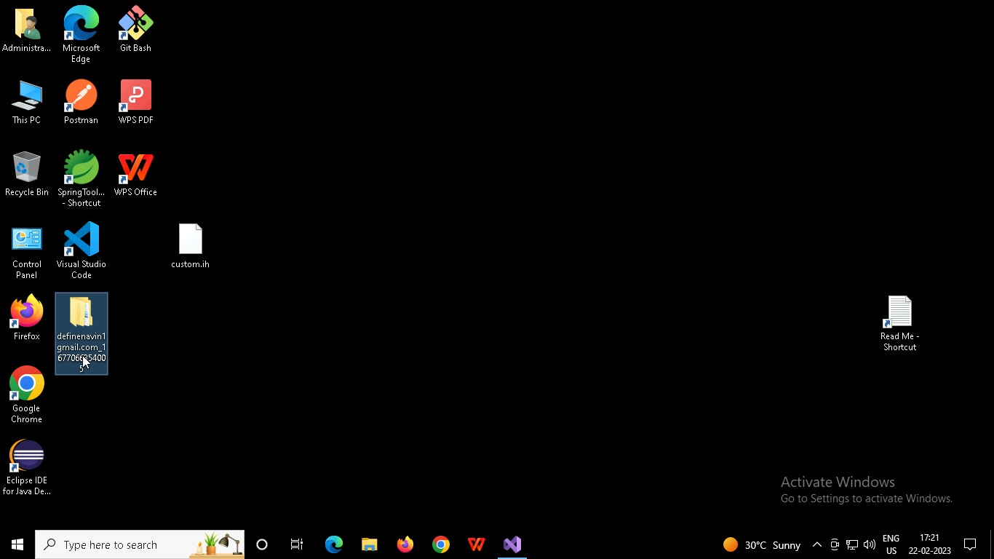

## Right click in folder and open Git Bash

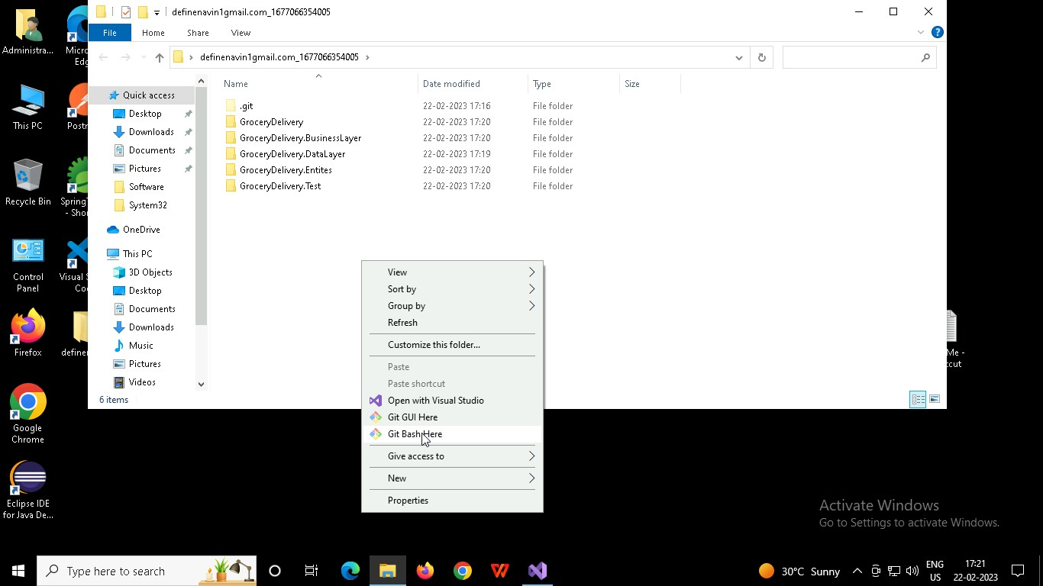

In Git bash terminal, run following commands

## git status

* 1. git add .

## git commit -m “First commit”

(You can provide any message every time you commit)

## git push

